Some of the LNF expectations for Year 1 include:
Using Number Skills
- Count reliably up to 20 objects.
- Read and write numbers to at least 20.
- Compare and order numbers to at least 20.
- Use number facts within 10, i.e. doubling and halving (e.g. 4 + 4) and bonds of 10 (e.g. 6 + 4).
- Find halves in practical situations.
- Add and subtract numbers involving up to 10 objects.
- Use ‘counting on’ strategies to add to collections, starting with the larger number, e.g. 8 + 5.
- Make a sensible estimate of a number of objects that can be checked by counting.
- Use different combinations of money to pay for items up to 20p.
- Find totals and give change from 10p.
Using Measuring Skills
- Use non-standard units to measure: length, height and distance, weight/mass and capacity.
- Use standard units of time to read ‘o’clock’.
- Use the concept of time in terms of their daily and weekly activities and the seasons of the year.
Using Data Skills
- Sort and classify objects using more than one criterion.
- Collect information by voting or sorting and represent it in pictures, objects or drawings.
- Make lists and tables based on data collected.
Developing Numerical Reasoning
- Identify steps to complete the task or reach a solution.
- Select appropriate mathematics and techniques to use.
- Select and use relevant number facts and mental strategies.
- Use everyday and mathematical language to talk about their own ideas and choices.
Supporting children in Year 1

A leaflet for parents
Help your child with numeracy

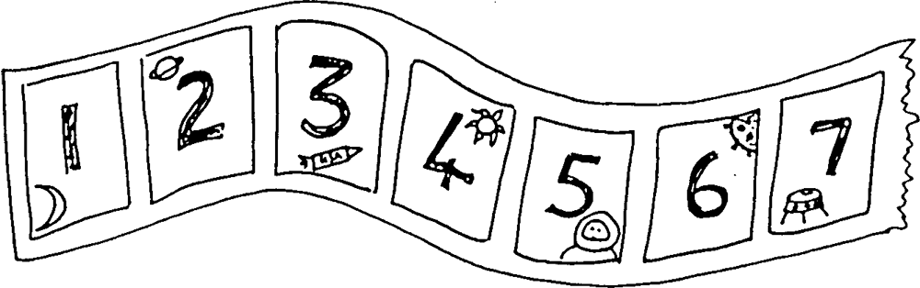


Secret numbers

Write the numbers 0 to 20 on a sheet of paper.
Ask your child secretly to choose a number on the paper. Then ask him/her some questions to find out what the secret number is, e.g.
- Is it less than 10?
- Is it between 10 and 20?
- Does it have a 5 in it?
He/she may answer only Yes or No.
Once you have guessed the number, it is your turn to choose a number. Your child asks the questions.
For an easier game, use numbers up to 10. For a harder game, use only five questions, or use bigger numbers.
Dice game
You need a 1–6 dice, paper and pencil.
Take turns.
Choose a number between 1 and 10 and write it down.
Throw the dice and say the dice number.
Work out the difference between the chosen number and the dice number,
e.g. if you wrote down a 2 and the dice shows 5, the difference is 3.
You could also draw a number line to help your child to see the difference between the two numbers.

How old?
Start with your child’s age. Ask your child:
How old will you be when you are one year older?
How old were you last year?
How old will you be 10 years from now?
and so on.
Cupboard maths
Choose two tins or packets from your food cupboard.
Ask your child to hold one in each hand and tell you which is heavier and which is lighter. (Check by reading the weight on each tin or packet.)
If he/she is right, they keep the lighter one. Then choose another item from the cupboard, trying to find one that is lighter still.
Carry on until your child has found the lightest item in the cupboard. It might be suitable to eat as a prize!
Track games
Make a number track to 20, or longer. Make it relevant to your child’s interests – sea world, space, monsters… Then play games on it.

Throw a dice. Move along that number of spaces. BUT before you move, you must work out what number you will land on. If you are wrong, you don’t move! The winner is the first to land exactly on 20. Now play going backwards to 1.
Throw a dice. Find a number on the track that goes with the number thrown to make either 10 or 20. Put a counter on it, e.g. you throw a ‘4’ and put a counter on either 6 or 16. If someone else’s counter is there already, you may replace it with yours! The winner is the first person to have a counter on eight different numbers.
Takings
For this game you will need a dice and a collection of small things such as Lego bricks, sticky shapes or dried beans. You will also need pencil and paper.
Take turns.
Roll a dice. Take that number of beans. Write down the number.
Keep rolling the dice and taking that number of beans. BUT, before you take them, you must write down your new total.
For example, Sally has seven beans. She throws 4. She has to work out how many she will have now. She starts counting from seven: eight, nine, ten, eleven. She writes 11.
You can only take your beans if you are right. The first person to collect 20 beans wins!

